

**Software Requirements Specification**

**for**

**Mumbai Tour and guide Management system**

**Version 1.0 approved**

**Prepared by Shivam Pawar (2019230068)**

**Vishal Salvi (2019230069)**

**Shreyas Patel (2018130037)**

**SPIT, MUMBAI**

**August 20,2020**

***Copyright © 1999 by Karl E. Wiegers. Permission is granted to use, modify, and distribute this document.***

***Software Requirements Specification for <Project>*** ***Page ii***

**Table of Contents**

|  |  |  |  |
| --- | --- | --- | --- |
| **Table of Contents ..........................................................................................................................** | | | **ii** |
| **Revision History ............................................................................................................................** | | | **ii** |
| **1.** | **Introduction ..............................................................................................................................** | | **1** |
|  | 1.1 | Purpose ............................................................................................................................................. | 1 |
|  | 1.2 | Document Conventions .................................................................................................................... | 1 |
|  | 1.3 | Intended Audience and Reading Suggestions................................................................................... | 1 |
|  | 1.4 | Product Scope ................................................................................................................................... | 1 |
|  | 1.5 | References......................................................................................................................................... | 1 |
| **2.** | **Overall Description ..................................................................................................................** | | **2** |
|  | 2.1 | Product Perspective .......................................................................................................................... | 2 |
|  | 2.2 | Product Functions ............................................................................................................................. | 2 |
|  | 2.3 | User Classes and Characteristics ...................................................................................................... | 2 |
|  | 2.4 | Operating Environment .................................................................................................................... | 2 |
|  | 2.5 | Design and Implementation Constraints ........................................................................................... | 2 |
|  | 2.6 | User Documentation ......................................................................................................................... | 2 |
|  | 2.7 | Assumptions and Dependencies ....................................................................................................... | 3 |
| **3.** | **External Interface Requirements ...........................................................................................** | | **3** |
|  | 3.1 | User Interfaces .................................................................................................................................. | 3 |
|  | 3.2 | Hardware Interfaces .......................................................................................................................... | 3 |
|  | 3.3 | Software Interfaces ........................................................................................................................... | 3 |
|  | 3.4 | Communications Interfaces .............................................................................................................. | 3 |
| **4.** | **System Features .......................................................................................................................** | | **4** |
|  | 4.1 | System Feature 1 .............................................................................................................................. | 4 |
|  | 4.2 | System Feature 2 (and so on)............................................................................................................ | 4 |
| **5.** | **Other Nonfunctional Requirements .......................................................................................** | | **4** |
|  | 5.1 | Performance Requirements ............................................................................................................... | 4 |
|  | 5.2 | Safety Requirements ......................................................................................................................... | 5 |
|  | 5.3 | Security Requirements ...................................................................................................................... | 5 |
|  | 5.4 | Software Quality Attributes .............................................................................................................. | 5 |
|  | 5.5 | Business Rules .................................................................................................................................. | 5 |
| **6.** | **Other Requirements ................................................................................................................** | | **5** |
| **Appendix A: Glossary....................................................................................................................** | | | **5** |
| **Appendix B: Analysis Models .......................................................................................................** | | | **5** |
| **Appendix C: To Be Determined List ............................................................................................** | | | **6** |

**Revision History**

|  |  |  |  |
| --- | --- | --- | --- |
| **Name** | **Date** | **Reason For Changes** | **Version** |
|  |  |  |  |
|  |  |  |  |
|  |  |  |  |
|  |  |  |  |

***Software Requirements Specification for <MTGMS>*** ***Page 1***

1. **Introduction**

**1.1** **Purpose**

This SRS describes the software functional and non-functional requirements for release 1.0 of the Mumbai tour guide and management system (MTGMS). This document is intended to be used by the members of the project team that will implement and verify the correct functioning of the system. Unless otherwise noted, all requirements specified here are high priority and committed for release 1.0.

**1.2** **Document Conventions**

When you read this SRS, certain words are represented in different fonts, typefaces, sizes, and weights. This highlighting is systematic; different words are represented in the same style to indicate their inclusion in a specific category. The types of words that are represented this way include the following:

**1.3** **Intended Audience and Reading Suggestions**

While the software requirement specification (SRS) document is written for a more general audience, this document is intended for individuals directly involved in the development of Tourism Management System. This includes software developers, project consultants, and team managers. This document need not be read sequentially; users are encouraged to jump to any section they find relevant.

**1.4** **Product Scope**

The Mumbai tour guide and management system (MTGMS) is an implementation of a managing Tourism website which helps the customers to search the availability and rent of various hotel rooms in particular places, along with the different packages available with the reservations. This project also covers various features like online registration of the users, history of tourism location, by adding, deleting or modifying the customer details or packages information. In general, this website would be designed to perform like any other Tourist management website available online.

**1.5** **References**

1. http://www.cse.iitd.ac.in/~cs5080212/Group08_(STUB)_SRS_Version_1.1.pdf
2. http://www.cse.chalmers.se/~feldt/courses/reqeng/examples/srs_example_2010_group2.pdf

***Software Requirements Specification for <MTGMS>*** ***Page 2***

1. **Overall Description**

**2.1** **Product Perspective**

Access to relevant and accurate information is at the heart of tourism, more so in this era of the Internet information overload has become a prevalent phenomenon and as such a serious issue for those seeking for appropriate information. Tourism Management System tries to bridge the gap by nothing what a tourist perceives as relevant so, the aim of this is TMS will assist tourists in gaining access to information on tourist location in India as well as get reviews about that location or book nearby hotel to stay also can check the specification of hotel and book hotel.

Tourist Location Review

Tourist Location History

Nearby Hotel Booking

User Login

Tourism Management System

Hotel Review

Email Verification

**2.2** **Product Functions**

* User Login and authentication.
* Search Tourist Place- User can search best tourist place in Mumbai.
* Location Review- User can get reviews of that place from those who previously visited.
* User can view images of tour place as well as get history or information regarding location.
* Hotel Booking- If user want to stay in hotel then they can book room in hotel.
* Make Payment- After booking the room in hotel user can pay the room rent.

***Software Requirements Specification for <MTGMS>*** ***Page 3***

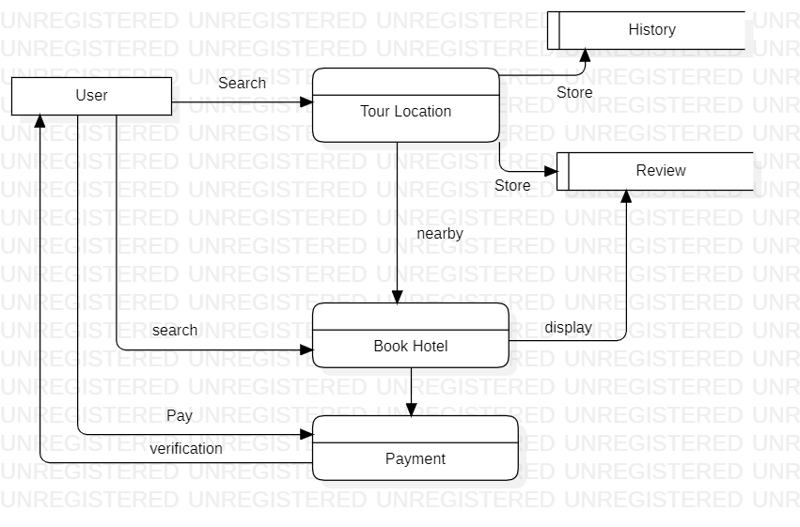

**2.3** **User Classes and Characteristics**

Tourist User: User can view details about tour location as well as use hotel system to book room.

**2.4** **Operating Environment**

The Mumbai tour guide and management system shall operate with all the Web browsers.

**2.5** **Design and Implementation Constraints**

CO-1: The system shall use MySQL database engine.

CO-2: All HTML code shall conform to the HTML 4.0 standard.

CO-3: All scripts shall be written in Python and Django

***Software Requirements Specification for <MTGMS>*** ***Page 4***

**2.6** **User Documentation**

UD-1: For new user system shall provide hierarchical structure so that user can get how to use web application

UD-2: The first time a new user access the system and on user demand therefore the system shall provide an online tutorial to allow to practice on how to get Mumbai tourist place history and information regarding same as well as hotel booking system

**2.7** **Assumptions and Dependencies**

AS-1: The system shall show of all the Mumbai tour guide and management system.

**3. External Interface Requirements**

**3.1 User Interfaces:**

UI 1: The first page will be the home page for the user.

UI 2: Second page would be places to visit.

UI 3: Third Page will give details about the hotels.

UI 4: All beautiful pictures of Bombay will be displayed in fourth page.

UI 5: If user want to book the tour, he/she would be directed to the registration page.

UI 6: User would be able to see the selected places and hotels.

UI 7: Payment page will be displayed and confirmation email will be sent to the user.

**3.2 Hardware Interfaces**

No hardware interfaces have been used.

***Software Requirements Specification for <MTGMS>*** ***Page 5***

**3.3 Software Interfaces**

**1. Search**

All visitors to the system can search for tourist centers in Bombay, as per specific location, district, category and season. They can get information about different recreational facilities available at each Tourist centers and information about facility providers, quality and cost.

**2. Registration**

The tourist who wishes to avail of the facilities has to register with the system giving all the details. He / she have to provide a user id and password.

**3. Online Booking**

In this module tourists can book online the following facilities: Hotels / restaurants.

They can also make online payment of bills for booking.

**4. Feedback**

Options to give feedback by the users.

**3.4 Communication Interface:**

**CI 1:**  User can ask the queries by sending an Email.

**CI 2:** System will send a confirmation mail once the booking is successfully completed.

**4. System Features**

**4.1 Guest Login**

**4.1.1 Description and Priority**

A person who has not yet logged in the system can view the website. To book the tour the user must first register and then login into the system and then book the tour.

***Software Requirements Specification for <MTGMS>*** ***Page 6***

**4.1.2 Stimulus/Response Sequences**

Stimulus: User opens the website.

Response: Various menus will be available for user.

**4.1.3 Functional Requirements**

Guest. Login: User must visit the website to select the places.

**4.2 Search for places and hotels.**

**4.2.1 Description and Priority:**

The user reads the reviews about the place and choose the place.

**4.2.2 Stimulus/Response Sequences:**  
 Stimulus: User clicks on the place.  
 Response: The nearest hotels according to the users choice will be displayed.

**4.2.3 Functional Requirements:**

Search places: User can search the nearby places to visit.

Contact: Connect through email.

**4.3 Register:**

**4.3.1 Description and Priority:**

If the user wants to book a tour then he/she need to register in the system.

**4.3.2 Stimulus/Response Sequences:**

Stimulus: User clicks on the signup.  
 Response: The registration form will be displayed in which user need to fill their details.

***Software Requirements Specification for <MTGMS>*** ***Page 7***

**4.3.3 Functional Requirements:**

Register: User need to fill all his/her details and verify their identity.

**4.4 Fill Details:**

**4.4.1** **Description and Priority:**

Now after registration user need to login into their account and fill the tour details.

**4.4.2 Stimulus/Response Sequences:**

Stimulus: User fill the details about the tour.

Response: The system will show the availability of the user request.

**4.4.3 Functional Requirements:**

Check. Availability: The system will check the availability of the rooms in hotels.

**4.5 Payment Option:**

**4.5.1 Description and Priority:**

Once everything is confirmed the user can pay through various online payment options available.

**4.5.2 Stimulus/Response Sequences:**

Stimulus: User fills all their details about payment.

Response: If everything is verified then system will accept the payment and Booking will be confirmed.

***Software Requirements Specification for <MTGMS>*** ***Page 8***

**4.5.3 Functional Requirements:**

Confirm. Booking: After the successful payment the tour will be booked.

**4.6 Email confirmation**

**4.6.1 Description and Priority:**

Once the booking is confirmed the user will get a confirmation email.

**4.6.2 Stimulus/Response Sequences:**

Stimulus: User confirms the booking

Response: In response the user will get a confirmation mail.

**4.6.3 Functional Requirements:**

1. Confirmation.id : After booking the user will get a confirmation mail.

1. **Other Non-functional Requirements**

**5.1** **Performance Requirements**

PE-1: The Mumbai tour guide and management system (MTGMS) application should be able to respond to the queries submitted by the customer without much delay.

PE-2: When a user searches for a tour location, the application should not take much time to return the results, similarly for the Hotel.

PE-3: Responses to queries shall take no longer than 7 seconds to load onto the screen after the user submits the query.

PE-4: The system shall display confirmation messages to users within 4 seconds after the user submits information to the system.

***Software Requirements Specification for <MTGMS>*** ***Page 9***

**5.2** **Safety Requirements**

No safety requirements have been identified

* 1. **Security Requirements**

SE-1: All network transactions that involve financial information or personally identifiable information shall be encrypted per BR-33.

SE-2: Users shall be required to log in to the Cafeteria Ordering System for all operations except viewing a menu.

**5.4** **Software Quality Attributes**

**Reliable:** For all services that rely on MTGMS for access control, lack of availability of the supported services. The product should not crash under any circumstance such as user entering invalid values, user trying to find unusual data etc. It should show appropriate message for every user generated message.

**Transparent:** Ideally, the user should not be aware that authentication is taking place beyond the requirement to enter a password.

**Scalable:** The system should be capable of supporting large number of client and servers. This suggests modular, distributed architecture

**Portable:** Our product will be portable to carry and will run in any machine provided it runs any Operating System.